Predictive Maintenance of Industrial Equipment’s using IoT and Machine Learning

Dr. N S Patankar, Arya Jadhav, Suyog Dighe, Tushar Patekar, Ritesh Gaikwad, Bushraa Shaikh

Engineering Students, Sanjivani College of Engineering, Kopargaon an Autonomous Institute affiliated to SPPU Pune, Department of Information Technology.

ABSTRACT

This study examines the predictive maintenance of industrial equipment. Through a Google form, we gathered various viewpoints from experts in the disciplines of Machine Learning (ML), the Internet of Things (IoT), and Information Technology. We learned from this survey that if we don't take any protective steps to maintain industrial equipment, a lot of rubbish will be produced, which will further contribute to pollution and several other issues, including a lack of equipment and many others. This study examines the predictive maintenance of industrial equipment. Through a Google form, we gathered various viewpoints from experts in the disciplines of machine learning, the Internet of Things, and information technology. We learned from this survey that if we don't take any proactive steps to maintain industrial equipment, a lot of rubbish will be produced, which will further contribute to pollution and several other issues, including a lack of equipment and many others. IoT is now widely used, and IoT devices are prevalent across numerous industries. To assure the best operation of machinery and processes, industrial IoT makes use of IoT devices and sensors to monitor machines and environments. One Industrial IoT technology that has gained interest recently is predictive maintenance, which tracks the health of equipment to predict the likely failure of components. Massive volumes of data are gathered, handled, and finally analyzed using Machine Learning algorithms to enable effective Predictive Maintenance.

Keywords: Research Paper, Technical Writing, Science, Engineering, and Technology

- INTRODUCTION

The goal of the Internet of Things (IoT) is to improve our quality of life. Since its introduction, practically every industry has taken advantage of it in some way. For instance, the use of IoT is widespread. For smart industry [7], agriculture [8, 9], housing [4, 5], the grid [5, 6], smart healthcare [1, 2], and other sectors. Information and communication technologies are used in the smart industry, also known as Industry 4.0, for effective productivity [8]. IoT, also known as Industrial IoT (IIoT) in the context of business, has recently attracted a lot of research attention [9], [10]. In the IIoT, various sensors are used to track the functioning of machinery or even entire production processes [20]. Predictive Maintenance (PM), a method used in the IIoT, has recently attracted attention.
In IIoT, several sensors are used to track the performance of machinery or perhaps an entire production cycle [20]. Predictive Maintenance (PM), a technique in IIoT, has recently gained popularity. PM's fundamental tenet is to keep an eye on equipment health using the Giacomo Vertical served as the associate editor in charge of overseeing this manuscript's review and giving final approval for publication. Assistance from sensing data to predict likely machine failure or degradation in the future. On the gathered data, PM applies Machine Learning (ML) to produce predictions. The obtained data is what determines how accurate the ML models are.
Streaming data from sensing devices to the cloud, where it is processed and modeled, is a conventional method of data collection in the IIoT. Sensing equipment produces vast amounts of data, either continuously or irregularly, frequently in a very short period. For instance, a machine may produce thousands of records in less than a second [16]. A terabyte of data can be produced by an automated facility per hour, claims the Cisco cloud index (2013–2018). To accomplish this, methods including sampling, compression, and filtering are employed. The amount of data sent to the cloud can be decreased thanks to these methods. For the ML models that use smaller datasets, there may be accuracy trade-offs.

- Related Work

Predictive maintenance definition and applications in industry, a description of IoT and machine learning technologies, and how they might enhance maintenance procedures. Justification for combining machine learning with IoT to allow data-driven, preventative maintenance solutions. Condition Monitoring via IoT: IoT sensor technologies reviewed for real-time data monitoring and collecting. Analysis of several condition monitoring sensor types, including temperature, vibration, and audio sensors. A discussion of the use of edge computing and wireless sensor networks for effective data collection and processing. Feature extraction and data analytics: Machine learning techniques are assessed for data analysis and pattern detection in predictive maintenance. Comparison of supervised and unsupervised learning methods for identifying anomalies and locating equipment faults. a summary of feature extraction techniques for removing pertinent features from sensor data. Diagnose and prognosis of faults Review of machine learning-based defect diagnosis techniques. Investigation of prognostic models to determine the remaining usable life (RUL) of industrial equipment. Discussion of how to combine time-series analysis and anomaly detection for the diagnosis and prediction of faults. Decision-Support Technologies: Analysis of IoT and machine learning-based decision support systems for preventive maintenance. An overview of the methods for scheduling maintenance and optimizing equipment uptime. Analyzing the cost-benefits of predictive maintenance solutions and their return on investment (ROI). Issues and Proposed Courses of Action: Data quality, scalability, and cybersecurity issues are identified, as are other issues with adopting IoT and machine learning for predictive maintenance. Exploration of upcoming research paths and trends, including explainable AI, edge intelligence, and hybrid modeling techniques.

- METHODS AND MATERIAL

Utilizing the Internet of Things to acquire and analyze data regarding assets, machinery, or equipment is known as IoT predictive maintenance. Data regarding the condition of the equipment is gathered by sensors and other instruments to identify any potential problems. The Internet of Things is frequently used in IoT predictive maintenance to monitor a variety of variables that could potentially point to equipment problems. These sensors and monitors are either installed on or incorporated into equipment. These devices collect asset data and send it over the network to other "things" like CMMS software, predictive maintenance software, or other intelligent manufacturing systems.
Other Internet of Things (IoT) technologies can run predictive maintenance analytics to find any potential problems that could lead to equipment failure by collecting and transmitting equipment performance data in real time. Organizations can use this process to more accurately forecast the likelihood of outages and other disruptions so they can plan for repair. Unnecessary downtime and upcoming outages.
Data collection: Industrial equipment is equipped with IoT sensors to gather a variety of data, including temperature, pressure, vibration, current, and other pertinent factors. These sensors produce real-time data while continuously monitoring the machinery.
Data Transmission: The gathered data is sent to a centralized system or cloud platform for storage and analysis. Depending on the specific needs and equipment, this can be accomplished using wired or wireless communication protocols.
Data preparation is the process of cleaning, normalizing, and transforming data into a format that is acceptable for analysis once it has been received. Outliers may need to be eliminated, missing values may need to be handled, and the data may need to be scaled properly.
In feature engineering, the behavior and performance characteristics of the equipment are captured by extracting pertinent features from the pre-processed data. Statistics, the outcomes of frequency domain analysis, or any other domain-specific parameters can all be included in these features.
Model Training: Historical data that includes both typical operating settings and known failure events is used to train machine learning algorithms. The retrieved attributes and the equipment's state of health are related to patterns and relationships that the algorithms learn.
Anomaly Detection: After the models have been trained, they are used to anticipate the equipment's current state of health. Continuously updated sensor data is supplied into the models, and any departures from the standard are recognized as potential abnormalities or warning indicators of impending failure.
When the predictive models identify anomalies or foresee possible failures, alerts or notifications are generated. By scheduling repairs or replacements in advance of a breakdown, maintenance professionals can use this knowledge to arrange maintenance actions proactively.
Continuous Improvement: The system can gather input on the accuracy of forecasts and modify the models when fresh data becomes available and maintenance tasks are carried out. The predictive maintenance system's accuracy and dependability are gradually increased through this iterative process.

IV. Figures and Tables

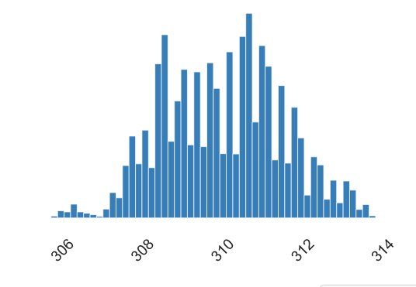
Figure 2: A sample line graph that shows Process temperature [K] and Real Number (R)

Processing Temperature:
- The term "process temperature" refers to the bare minimum temperature of the heating medium that must be maintained in accordance with the process schedule.
- PT is represented in the graph above (Fig.2) by the real number (R) and the letter (K).
- According to the information up above, the product's minimum process temperature is 305.7 K.
- The process temperature's highest value is 313.8 K.
- Consequently, a product's average mean process temperature is roughly 310.0055 K.

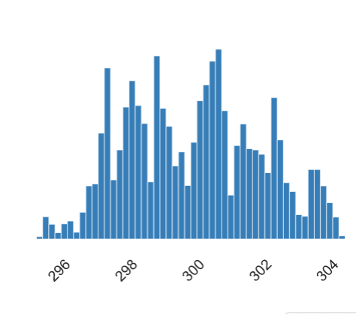
Figure 1: A sample line graph that shows Air temperature [K] and Real Number (R)

Air Temperature:

- When the climate changes due to hot or cold weather, the term "air temperature" is used.
- The product's minimum air temperature is 295.3 K, as can be seen from the graph above. (Fig.1)
- Additionally, 304.5 K is the highest possible value for air temperature.
- The product has a 300.0049 K. average mean air temperature.

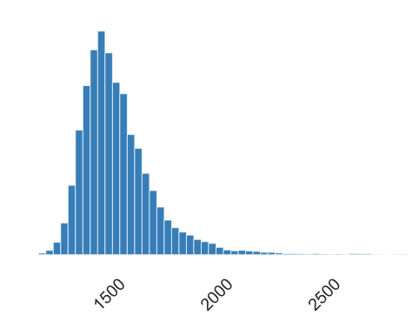
Figure 3: A sample line graph that shows Rotational Speed [rpm] and Real Number[R]
Speed of Rotation:
- Information about rotational speed is displayed in the above graph. (Fig.3)
- A rotating system's rotational speed, also known as speed or speed of rotation, can be calculated as the number of rotations it completes in a predetermined amount of time.
- Rotational speed is measured in rpm.
- The product in the graph above has a minimum rotational speed of 1168 rpm.
- Additionally, 1168 rpm is the maximum rotating speed.
- In the graph above, the average mean rotational speed is 1538.7761 rpm.

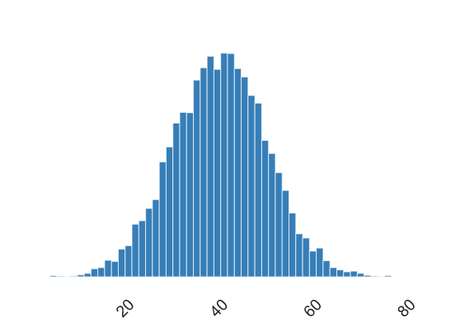
Figure 4: A sample line graph that shows Torque [Nm] and Real Number (R)
Torque:

- Data on torque are displayed in the above graph. (Fig.4)
- An axial rotational force that twists or turns is known as a torque.
- The SI unit for torque is Nm.
- According to the above graph, the minimum torque is 3.8 Nm.
- And 76.6 Nm. is the maximum value of torque.
- The mean torque value is 39.98691 Nm on average.

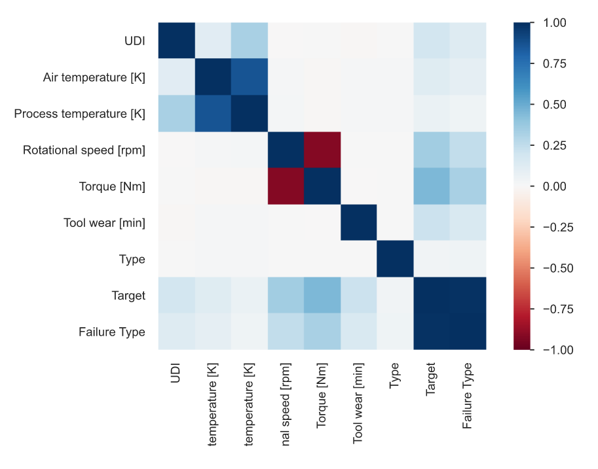
Figure 3: Heat-map [Correlations]
CONCLUSION

Reduced Downtime: By anticipating failures, maintenance tasks can be conducted during downtime that is scheduled, reducing unplanned shutdowns and their related costs. Cost savings: Predictive maintenance optimizes maintenance plans, minimizing the need for expensive emergency repairs and unneeded maintenance actions. Extended Equipment Lifespan: By taking care of problems before they become serious, proactive maintenance procedures can increase the lifespan of industrial equipment. Greater Operational Efficiency: Predictive maintenance allows for improved resource allocation because it focuses maintenance efforts on the equipment that requires them, saving time and resources on pointless inspections. Enhanced Safety: By decreasing the likelihood of accidents or incidents brought on by malfunctioning equipment, anticipating future equipment failures enhances safety.

- REFERENCES

- Li, S., Xu, L., & Wang, X. (2017). A review of industrial wireless networks in the context of Industry 4.0. IEEE Access, 5, 6717-6732.
- Sharma, A., & Thakur, M. (2018). Predictive maintenance using machine learning and IoT. Procedia Computer Science, 132, 1572-1581.
- Boulton, W. R., & Leschinsky, A. (2019). Predictive maintenance using IoT and machine learning for the power industry. In 2019 IEEE Texas Power and Energy Conference (TPEC) (pp. 1-5). IEEE.
- Sridhar, R., Venkatesh, A., & Sridhar, V. (2020). Predictive maintenance of industrial equipment using machine learning and IoT. In 2020 International Conference on Power Electronics, Smart Grid and Renewable Energy (PESGRE) (pp. 1-6). IEEE.
- Khan, M. F. H., Hasan, M. R., & Islam, M. S. (2019). Predictive maintenance of industrial machines using IoT and machine learning. In 2019 International Conference on Advances in Electrical Engineering (ICAEE) (pp. 110-115). IEEE.
- Suh, S., & Yang, S. (2020). Industrial equipment condition prediction using machine learning based on industrial IoT data. Applied Sciences, 10(2), 696.
- Zhang, X., Li, H., Chen, Y., Wang, J., & Huang, J. (2020). Predictive maintenance of industrial equipment based on machine learning and IoT. In 2020 5th International Conference on Measurement, Information and Control (ICMIC) (pp. 492-496). IEEE.
- Sisinni, E., Saifullah, A., Hancke, G. P., & Hancke Jr, G. P. (2018). Industrial Internet of Things: Challenges, opportunities, and directions. IEEE Transactions on Industrial Informatics, 14(11), 4724-4734.
- Sharma, S., Rani, S., & Singh, K. (2019). A survey on predictive maintenance using machine learning techniques. International Journal of Computer Applications, 182(49), 13-18.
- Liu, Y., Pasquier, M., & Gousseau, Y. (2019). Deep learning for time-series analysis: a review. arXiv preprint arXiv:1809.04356.
- Lin, J., Wei, G., Sun, X., Yan, Z., & Luo, B. (2018). Predictive maintenance based on machine learning in intelligent manufacturing. IEEE Access, 6, 69029-69037.
- Gao, R. X., Yan, R., & Chen, X. (2019). Machine learning for gear health monitoring: A review. Mechanical Systems and Signal Processing, 116, 678-698.
- Wang, X., Zhu, J., Xie, W., & Deng, Z. (2019). Deep learning for smart manufacturing

